**GIT Document**

**Step 01: Download and Install GIT**

[**https://git-scm.com/download/win**](https://git-scm.com/download/win)

**Step 02: Download and Install Tortoise Git**

[**https://tortoisegit.org/download/**](https://tortoisegit.org/download/)

**Step 03: Login you Github Account**

**Step 04: Navigate to Any Repository on GitHub.**

**Step 05: Copy the Repository URL from the Address Bar**

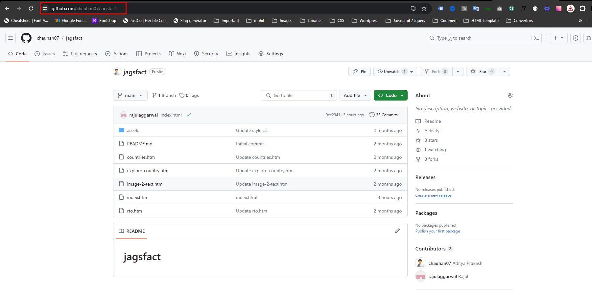

**Step 06: Create a Folder on Your Local Machine for Cloning the Repository.**

**Step 07: Right-click Inside the Folder and Select "Git Clone."**

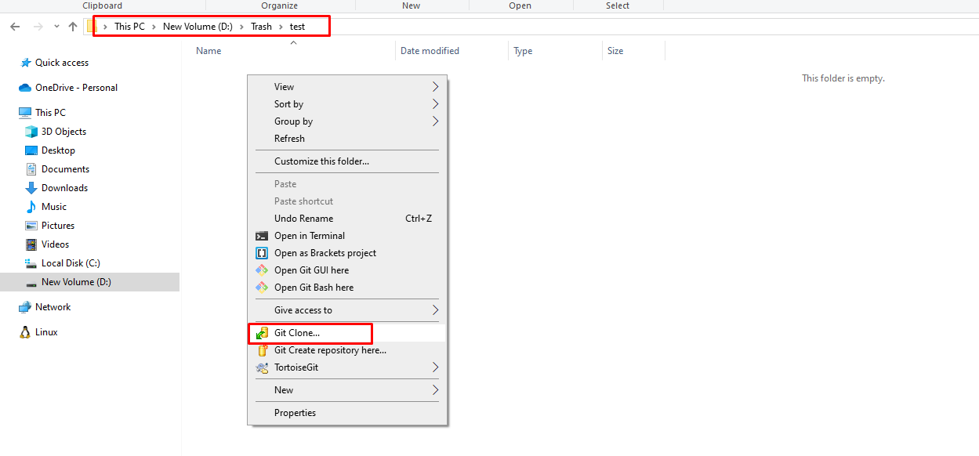

**Step 08: Final Step: Make Changes to Files. Right-click to Commit Changes.**

**Note : Before committing, switch branches if necessary. While committing, a authentication popup will appear from githup so authenticate it.**

**Thankyou 🙂**